WEST GODAVARI INSTITUTE OF SCIENCE AND ENGINEERING
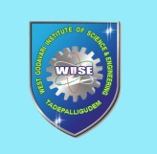
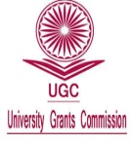
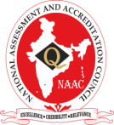
An AUTONOMOUS Institution
(Approved by AICTE, New Delhi and Affiliated to JNTUK-Kakinada)
An ISO 9001 : 2015 Certified College, Accredited ByNAAC
Avapadu, Prakasaraopalem, Nallajerla Mandal, E.G.Dist, A.P–534 112. Cell : 99512 77789, E-mail : principal.wise@gmail.com, Website : www.wise.ac.in

NSS Committee

S.No. | Member Name | Designation | Category/Position
1 | Dr. M.Aravindkumar | Principal | Chairman
2 | Mr.K.Muralidhar | Assoc. Prof. ME Dept. | Coordinator
3 | Dr.A.S.Prasad | Head of MBA Dept. | Member
4 | Mr.N.Prasanna kumar | Asst.Prof. MBA Dept | Member
5 | Mr.M.Rajesh | Asst.Prof. ECE Dept. | Member
6 | Mr.N.Kondayya | Asst.Prof. ME Dept | Member
7 | Mr.K.Jayaramakrishna | Assoc. Prof. S&H Dept. | Member
8 | Mr.S.Rajeev | Asst.Prof. CSE Dept | Member
9 | Mr.N.Durgaprasad | Student Volunteer, ECE | Member
10 | Mr.P.Swaroop | Student Volunteer, CSE | Member
11 | Mr.A.Raju | Student Volunteer, AIDS | Member
12 | Mr.K.BalaSai | Student Volunteer, ME | Member

